Lab 5

Exercise 1

A screen shot of the make command output for a successful compile

A screen shot of the program’s successful run for 10,000 values



Exercise 2

A screen shot of the make command output for a successful compile

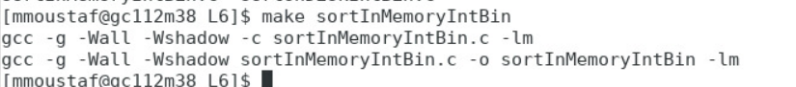

A screen shot of the program’s successful run.



Exercise 3

A screen shot of the make command output for a successful compile.



A screen shot of the program’s successful run.

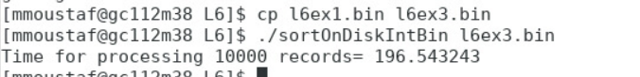

A brief set of thoughts about the relative speeds of running the two sorting programs

There is a huge difference between the running time of both algorithms. It took less than a second to run the first algorithm using memory, while it took more than 196 seconds to run the second algorithm on disk. I would always use the memory if that is the case.

Exercise 4

A screen shot of the make command output for a successful compile

